Experiment No : 2
Implement Multi Regression, Lasso, and Ridge Regression on real-world datasets

1. Dataset Source
The dataset used for this experiment is the Medical Insurance Cost Dataset.
Source (Kaggle):
https://www.kaggle.com/datasets/mirichoi0218/insurance
The dataset was downloaded in CSV format and used for model implementation in Google Colab.

2. Dataset Description
The Medical Insurance dataset contains information related to individuals and their medical insurance costs. The dataset includes both numerical and categorical features such as age, sex, body mass index (BMI), number of children, smoking status, and region.
- Number of Instances: 1338
- Features: age, sex, bmi, children, smoker, region
- Target Variable: charges (continuous insurance cost)
This dataset is suitable for regression problems with multiple input variables and is commonly used in real-world predictive modeling tasks.

3. Mathematical Formulation of the Algorithms

🔹 Multiple Linear Regression
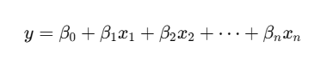
Multiple Linear Regression models the relationship between a dependent variable and multiple independent variables as:

Where:
- yyy = predicted insurance charges
- β0\beta_0β0​ = intercept
- β1,β2,…,βn\beta_1, \beta_2, \ldots, \beta_nβ1​,β2​,…,βn​ = regression coefficients

🔹 Ridge Regression (L2 Regularization)
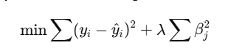
Ridge Regression adds an L2 penalty term to the linear regression cost function:

This helps in reducing model complexity and handling multicollinearity.

🔹 Lasso Regression (L1 Regularization)
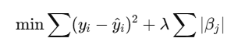
Lasso Regression adds an L1 penalty term to the cost function:

This can shrink some coefficients to zero, effectively performing feature selection.

4. Algorithm Limitations
- Multiple Linear Regression:
Assumes linear relationships and is sensitive to outliers and multicollinearity.
- Ridge Regression:
Reduces overfitting but does not eliminate irrelevant features completely.
- Lasso Regression:
Can perform feature selection but may behave inconsistently when predictors are highly correlated.

5. Methodology / Workflow
The experimental workflow followed these steps:
- Dataset collection from Kaggle
- Data preprocessing (handling missing values and encoding categorical features)
- Feature-target separation
- Splitting the dataset into training and testing sets
- Feature scaling
- Training Multiple Linear, Ridge, and Lasso Regression models
- Model evaluation using regression metrics
- Hyperparameter tuning using GridSearchCV
- Performance comparison and result analysis

6. Performance Analysis
The performance of the regression models was evaluated using Mean Absolute Error (MAE), Mean Squared Error (MSE), Root Mean Squared Error (RMSE), and R² Score.
The results show that Ridge and Lasso Regression help in reducing overfitting and improving the generalization capability of the model compared to standard Multiple Linear Regression.

7. Hyperparameter Tuning
Hyperparameter tuning was performed using GridSearchCV to identify the optimal value of the regularization parameter α\alphaα for both Ridge and Lasso Regression models. The tuned models achieved better cross-validation performance, indicating improved generalization on unseen data.

Code:

# STEP 1: Import Libraries
import numpy as np
import pandas as pd
import matplotlib.pyplot as plt

from sklearn.model_selection import train_test_split, GridSearchCV
from sklearn.preprocessing import StandardScaler
from sklearn.linear_model import LinearRegression, Ridge, Lasso
from sklearn.metrics import mean_absolute_error, mean_squared_error, r2_score

# STEP 2: Load Dataset
df = pd.read_csv("/content/insurance.csv")
print("Dataset Preview:\n", df.head())
print("\nDataset Shape:", df.shape)

# STEP 3: Data Preprocessing
print("\nMissing Values:\n", df.isna().sum())

# One-hot encode categorical columns
df_encoded = pd.get_dummies(df, drop_first=True)

# STEP 4: Features & Target
# Target = charges
X = df_encoded.drop(columns=["charges"])
y = df_encoded["charges"]

# STEP 5: Train-Test Split

X_train, X_test, y_train, y_test = train_test_split(
X, y, test_size=0.2, random_state=42
)

# STEP 6: Feature Scaling
scaler = StandardScaler()
X_train_scaled = scaler.fit_transform(X_train)
X_test_scaled = scaler.transform(X_test)

# PART A: Multiple Linear Regression
mlr = LinearRegression()
mlr.fit(X_train_scaled, y_train)
y_pred_mlr = mlr.predict(X_test_scaled)

print("\n===== MULTIPLE LINEAR REGRESSION =====")
print("MAE:", mean_absolute_error(y_test, y_pred_mlr))
print("MSE:", mean_squared_error(y_test, y_pred_mlr))
print("RMSE:", np.sqrt(mean_squared_error(y_test, y_pred_mlr)))
print("R2 Score:", r2_score(y_test, y_pred_mlr))

# PART B: Ridge Regression
ridge = Ridge(alpha=1.0)
ridge.fit(X_train_scaled, y_train)
y_pred_ridge = ridge.predict(X_test_scaled)

print("\n===== RIDGE REGRESSION =====")
print("MAE:", mean_absolute_error(y_test, y_pred_ridge))
print("MSE:", mean_squared_error(y_test, y_pred_ridge))
print("RMSE:", np.sqrt(mean_squared_error(y_test, y_pred_ridge)))
print("R2 Score:", r2_score(y_test, y_pred_ridge))

# PART C: Lasso Regression
lasso = Lasso(alpha=0.01, max_iter=10000)
lasso.fit(X_train_scaled, y_train)
y_pred_lasso = lasso.predict(X_test_scaled)

print("\n===== LASSO REGRESSION =====")
print("MAE:", mean_absolute_error(y_test, y_pred_lasso))
print("MSE:", mean_squared_error(y_test, y_pred_lasso))
print("RMSE:", np.sqrt(mean_squared_error(y_test, y_pred_lasso)))
print("R2 Score:", r2_score(y_test, y_pred_lasso))

# PART D: Hyperparameter Tuning (Ridge & Lasso)
ridge_params = {"alpha": [0.01, 0.1, 1, 10, 100]}
ridge_grid = GridSearchCV(Ridge(), ridge_params, cv=5, scoring="r2")
ridge_grid.fit(X_train_scaled, y_train)

print("\n===== RIDGE HYPERPARAMETER TUNING =====")
print("Best Alpha:", ridge_grid.best_params_)
print("Best CV R2:", ridge_grid.best_score_)

lasso_params = {"alpha": [0.001, 0.01, 0.1, 1, 10]}
lasso_grid = GridSearchCV(Lasso(max_iter=10000), lasso_params, cv=5, scoring="r2")
lasso_grid.fit(X_train_scaled, y_train)

print("\n===== LASSO HYPERPARAMETER TUNING =====")
print("Best Alpha:", lasso_grid.best_params_)
print("Best CV R2:", lasso_grid.best_score_)

# Graph 1: Actual vs Predicted (Best model: Ridge)
plt.figure(figsize=(6,4))
plt.scatter(y_test, y_pred_ridge, alpha=0.6)
plt.xlabel("Actual Charges")
plt.ylabel("Predicted Charges")
plt.title("Ridge Regression: Actual vs Predicted")
plt.show()

# Graph 2: Model Comparison (R2 Score)
models = ["MLR", "Ridge", "Lasso"]
r2_scores = [
r2_score(y_test, y_pred_mlr),
r2_score(y_test, y_pred_ridge),
r2_score(y_test, y_pred_lasso)
]

plt.figure(figsize=(6,4))
plt.bar(models, r2_scores)
plt.xlabel("Models")
plt.ylabel("R2 Score")
plt.title("Model Comparison (R2 Score)")
plt.show()

Output:
Dataset Preview:

age sex bmi children smoker region charges
0 19 female 27.900 0 yes southwest 16884.92400
1 18 male 33.770 1 no southeast 1725.55230
2 28 male 33.000 3 no southeast 4449.46200
3 33 male 22.705 0 no northwest 21984.47061
4 32 male 28.880 0 no northwest 3866.85520

Dataset Shape: (1338, 7)

Missing Values:
age 0
sex 0
bmi 0
children 0
smoker 0
region 0
charges 0
dtype: int64

===== MULTIPLE LINEAR REGRESSION =====
MAE: 4181.194473753651
MSE: 33596915.851361476
RMSE: 5796.284659276274
R2 Score: 0.7835929767120722

===== RIDGE REGRESSION =====
MAE: 4182.796596583267
MSE: 33604973.53996331
RMSE: 5796.979691180858
R2 Score: 0.7835410749121385

===== LASSO REGRESSION =====
MAE: 4181.197631564924
MSE: 33596958.0103243
RMSE: 5796.288295998078
R2 Score: 0.7835927051545373

===== RIDGE HYPERPARAMETER TUNING =====
Best Alpha: {'alpha': 10}
Best CV R2: 0.7331848853412936

===== LASSO HYPERPARAMETER TUNING =====
Best Alpha: {'alpha': 10}
Best CV R2: 0.7331897755565008

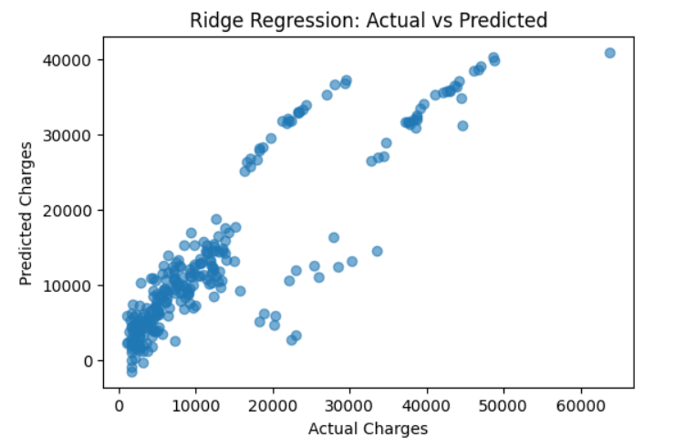
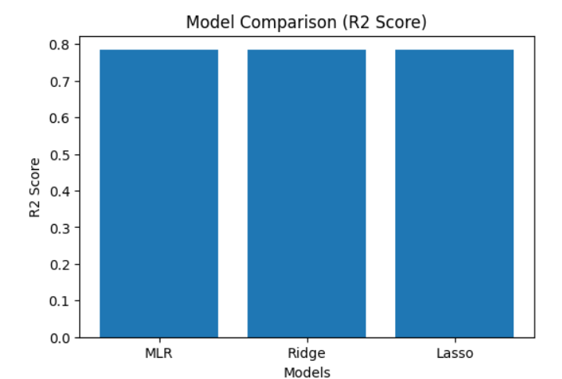

Conclusion
In this experiment, Multiple Linear Regression, Ridge Regression, and Lasso Regression were successfully implemented on a real-world medical insurance dataset. The use of regularization techniques improved model stability and generalization. This experiment demonstrates the importance of model selection and hyperparameter tuning in building robust regression models.

